Getting Started
This is a short set of instructions to get you started with the KanbanSim application. More detailed information, and tips are in our support knowledge base:
http://support.focusedobjective.com
Remember: By using this software you have agreed to our End User License Agreement – a copy of it is posted here – http://www.focusedobjective.com/legal

Opening an example file
- Click on the “Kanban Examples” or “Scrum Examples”ribbon tab.
- Choose an example file, by left-clicking on it to open that example
  - Hovering over the icon of a file will show a tooltip describing that example
  - Depending on the window size, the files are grouped and resized
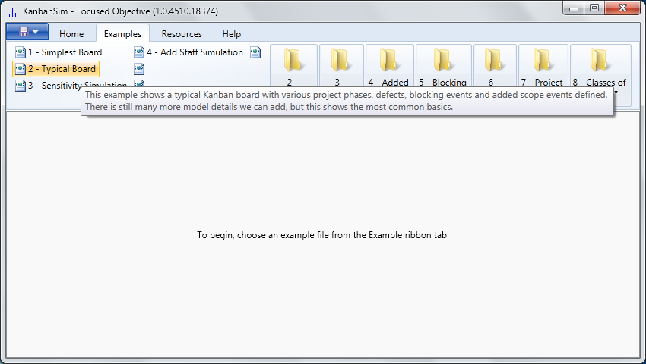
2
1

Viewing the Visual Board
When a file is opened it is automatically simulated visually. The result of this visual simulation is shown in the Board view on the Home ribbon tab.
- Click on the “Home” ribbon tab.
- Click on the “Board” button in the “View” ribbon group
  - Drag the slider near the top of the board to progress through simulation time intervals
  - Notice the legend at the bottom of the window.

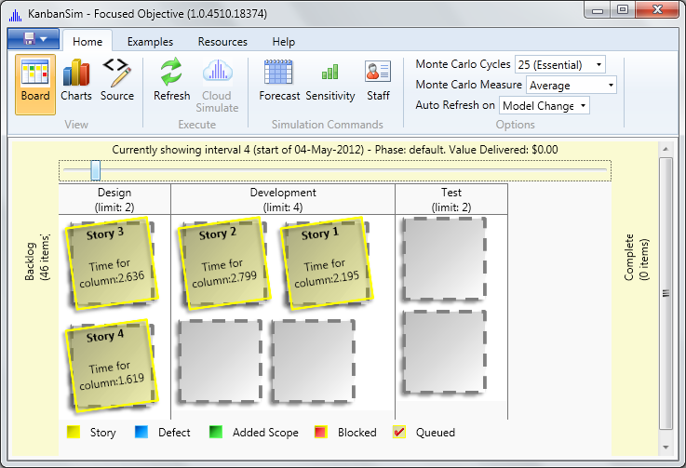
Unused WIP Position
Card
Info-Bar
Legend
Slider

Exploring the Charts
When a file is opened it is also simulated for charting purposes. To see the charts –
- Click on the “Home” ribbon tab.
- Click on the “Charts” button in the “View” ribbon group
  - Click on the Cumulative Flow tab in this window to see the Cumulative Flow chart
    - Turn on/off a column series by checking or un-checking the box next to that column name in the legend
    - Click and drag to zoom into the chart; Double-click anywhere on the chart to return it to full size
  - Click on the Statistics tab in this window to see a variety of other charts
    - Choose a chart from the drop-down list
    - Notice the description that displays when a chart is chosen
    - Some charts require a sub-selection; a second combo-box appears when this is necessary
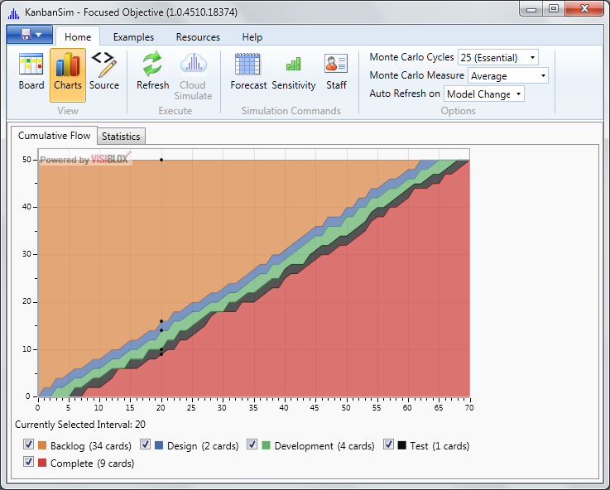
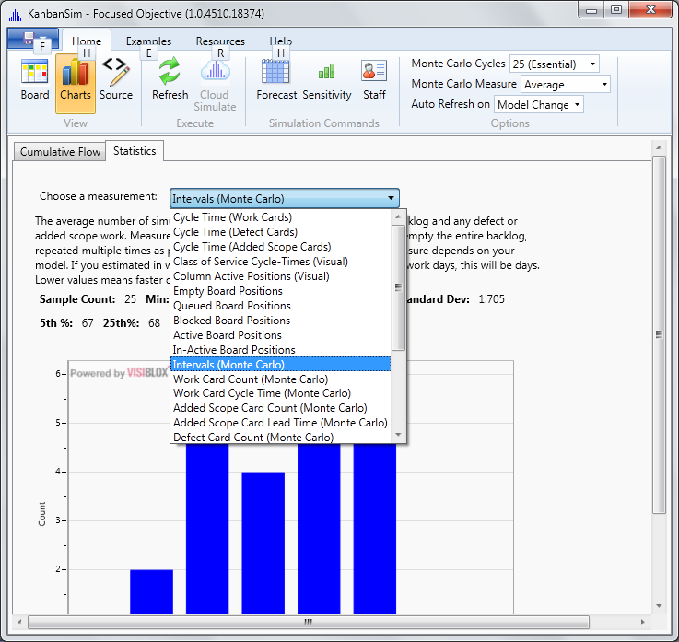

Changing the Number of Simulation Cycles
The number of simulation iterations (or cycles) that are performed for Monte Carlo simulation is controlled from the option drop-down on the “Home” ribbon tab.
- Click on the Home ribbon tab.
- Drop-down the options for Monte Carlo Cycles, and choose the number you want
  - Different license levels allow more or less cycles
  - The more cycles, the longer it takes to simulate
  - If you aren’t using the Monte Carlo charts in the Statistics tab, then set this to None
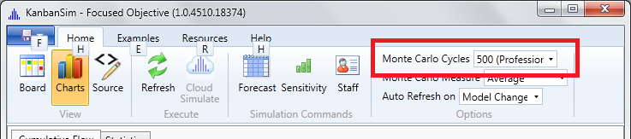

Getting Help
- Click on the “Help” ribbon tab.
- Choose a help resource from those listed on the ribbon.

Going to the Knowledge Base
- Click on the “Help” tab
- Click on the “Support” button in the “Online” group

Opening, Closing and Saving Files
The File menu is opened by clicking on the small disk icon in the top-leftmost position of the ribbon toolbar.
Tip: Open Folder is a special command that opens a full set of folders, resources and help links from a folder structure defined by Focused Objective. See our Knowledge Base for more information.
